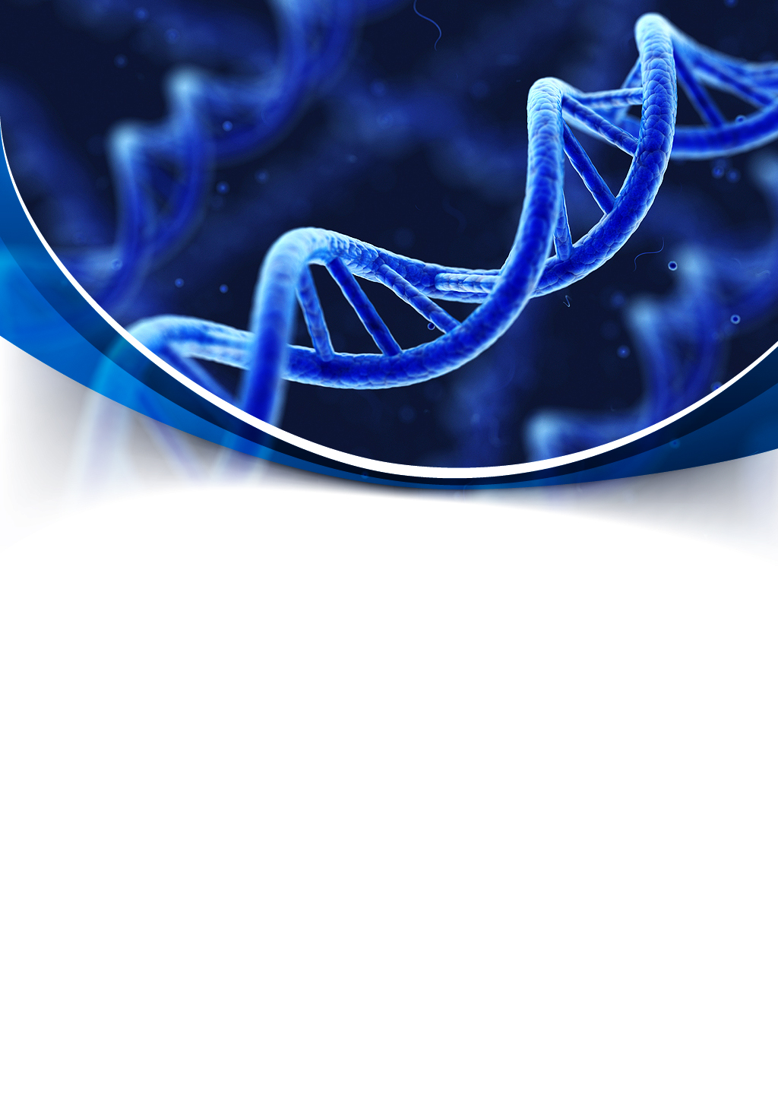



Contents

1. Team 3

1.1 Lubomir Georgiev 10B – Scrum Trainer 3

1.2 Krasimira Ruseva 10B – Backend Developer 3

1.3 Toni Chodzhorova 10G – Backend Developer 3

1.4 Lorena Hristova 10B – Designerr 3

2.Goals 4

3. Stages of development 4

3.1 Start of the project and planning 4

4.Stages of realization 5

4.1 Planning 5

4.3 Testing 5

5.Application Description and structure 7

5.1 Structure 5

5.2 Description 5

# 1. Team

# 1.1 Lubomir Georgiev 10B – Scrum Trainer

I am the leader and I organized my team. I worked on the application. I created the repo and the files inside so that my team could work on them. I made projects and issues so we could work better.

# 1.2 Krasimira Ruseva 10B – Backend Developer

I made the presentation, the logo in Photoshop and the documentation. Together with Toni we made the scheme for the application.

# 1.3 Toni Chodzhorova 10G – Backend Developer

I made the QA documentation and worked on the documentation and the algorithm scheme for the application with Krasimira.

# 1.4 Lorena Hristova 10B – Designer

I helped Krasimira with the presentation.

Интр

# 2.Goals

Our goal is to create a game named DNA using C++. That is a game with 10 questions related to the subject of biology.

We tried to create the game DNA in an interesting and educational for all people way, so people who want to use it to become interested in programming and to learn about different programming operations. We want our game to be useful for our visitors and help them to develop starting knowledge related to biology.

# 3. Stages of development

# 3.1 Start of the project and planning

After we formed our team, we got together and decided what everyone's role is, and then the leader of our team registered us. We decided when we are going to have meetings and then we were ready to start.

We started our work using Microsoft teams as communication platforms. We discussed ideas and gave different suggestions on how each of us sees the final product. After we reached a consensus, we decided what part of the project everyone should do and we started working. If there were any problems we helped each other in the process of work.

# 4. Stages of realization

# 4.1 Planning

After we formed our team and assigned the roles, and we organized when our meetings would take place.

**4.2 Realization**

We decided what is the project going to include. During the whole process we used MS Teams to communicate with one another. We met frequently to discuss about the progress, the due dates that the Scrum Trainer assigned and helping one another.

# 4.3 Testing

Our Q&A Engineer made sure that all used functions, cycles work and pointed out the bugs and mistakes, so that they could fixed as soon as possible**.**

# 5. Site description and structure

# 5.1 Structure

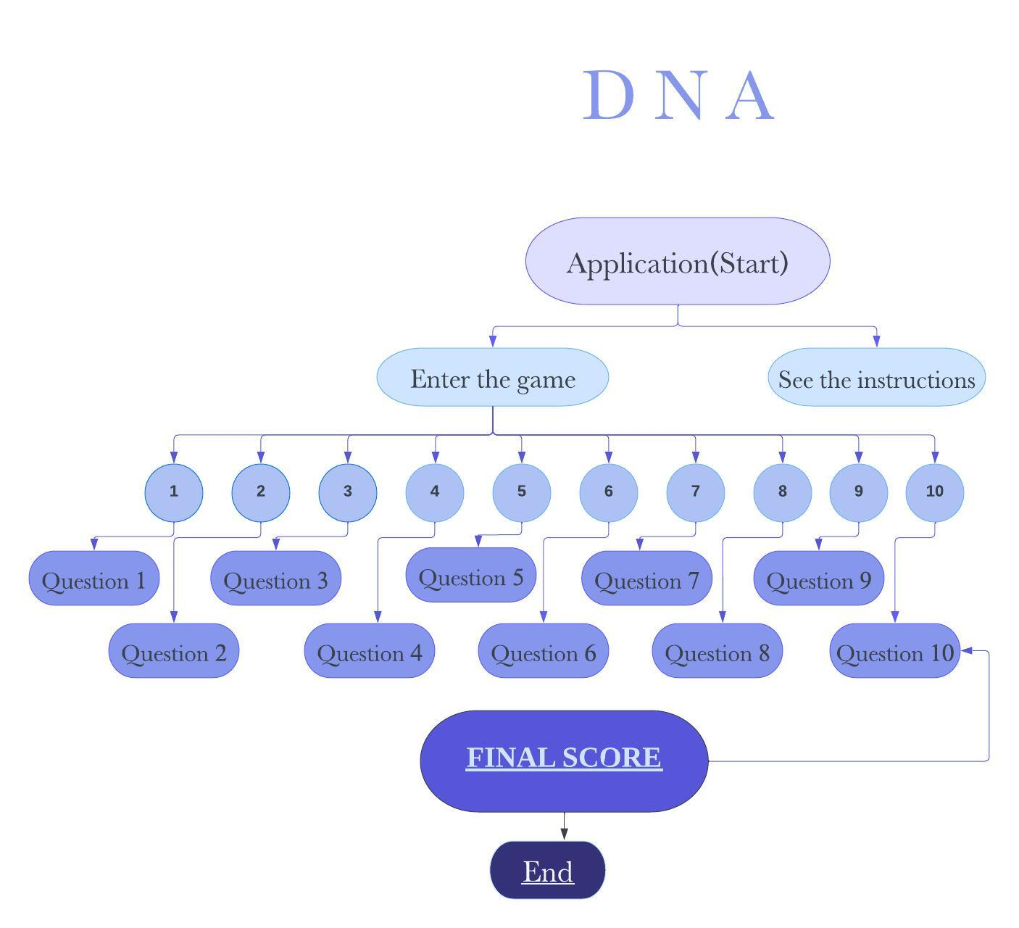

# 5.2 Description

Here in our game, you will find the menu of the game in where you will find 10 boxes which you can click. By clicking on the boxes, you will be sent to a new field where you can see the selected question and you will be able to answer it. You will see your score which may go up or stay the same according to what you have answered and whether it is correct or not. At the end, you will see your final score.